# Styles Guide

**Colours:**



Primary colour Secondary/link Colour Button -Primary Body text

#E7472E #4F2A3) #004d6d |52908B #5b6b79 | E5E2CA

**Typography:**

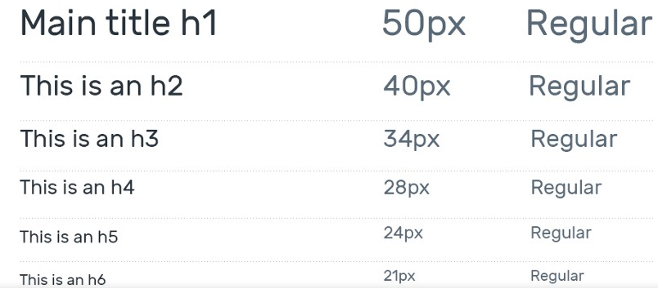Lato sans-serif for heading

Lato sans for body text fonsize – 20px

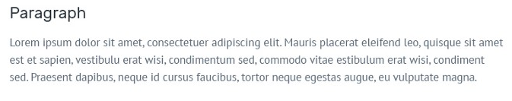 **Button**